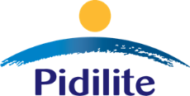

Roff, Pidilite's cutting-edge tile fixing adhesive brand, unveils a quirky pan-India TV commercial launch

~Brand conveys ‘Magar ki Jakad’ proposition through a humorous plot~

~The TVC highlights Roff's superiority over old method of fixing tiles.
Link: https://youtu.be/q23yWvgPIZo
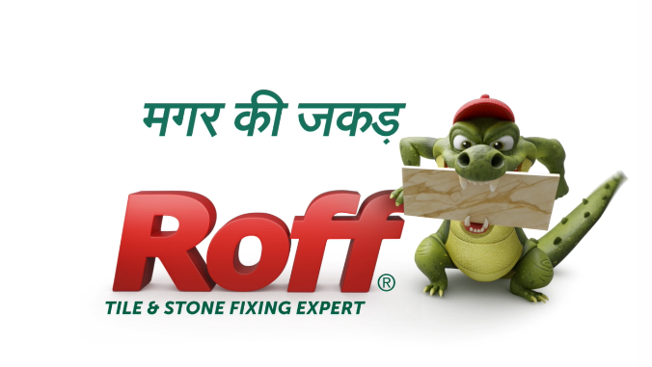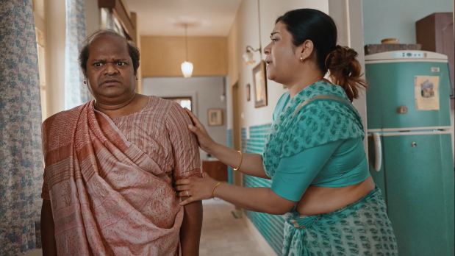
India, 19th June, 2023: Pidilite, a leading manufacturer of construction and specialty chemicals has announced the launch of new television commercial (TVC) for its revolutionary tile adhesive brand, Roff. The TVC, conceptualized by Ogilvy, showcases the superior qualities of Roff tile adhesive while addressing common tile installation issues faced by customers.

In a delightfully quirky manner, the TVC captures the customer’s frustration with cracked tiles, debonding, falling tiles, and unaesthetic appearance resulting from cement use. Through entertaining visuals and engaging storytelling, the TVC showcases how Roff triumphantly tackles these challenges, offering a reliable and durable solution.

Commenting on the consumer awareness campaign for Roff, Sudhanshu Vats, Deputy Managing Director, Pidilite Industries Ltd., said, " At Pidilite, pioneering in emerging categories is a core value that drives us. Our brand Roff is aimed at transforming the way tiles are fixed in India. The nationwide launch of our new Roff TV commercial underscores our unwavering commitment to raising awareness and enhancing customer experiences. Roff products embody cutting-edge technology, blending global expertise with local intelligence. They enable contractors, architects to create long-lasting beautiful tile and stone creations without any worry. Through this initiative our objective is to inform and empower customers to make well-informed choices.”

Piyush Pandey, Chairman of Global Creative & Executive Chairman, India said, “It’s a great innovative product and therefore one of the most innovative demonstrations of the benefit. It explains it all in a consumer friendly and entertaining fashion.”
The new Roff TVC will play on major television networks, digital platforms, and social media channels, ensuring wide visibility and reach to consumers seeking reliable and superior tile fixing solutions.

About Pidilite:
Pidilite Industries Limited is a leading manufacturer of adhesives and sealants, construction chemicals, craftsmen products, DIY (Do-It-Yourself) products and polymer emulsions in India. Our products range also includes paint chemicals, automotive chemicals, art materials and stationery, fabric care, maintenance chemicals, industrial adhesives, industrial resins and organic pigments & preparations. Most of the products have been developed through strong in-house R&D. Our brand name Fevicol has become synonymous with adhesives to millions in India and is ranked amongst the most trusted brands in the country. Some of our other major brands are M-Seal, Fevikwik, Fevistik, Roff, Dr. Fixit, Araldite and Fevicryl.

About Roff:
Roff, from the house of Pidilite Industries Ltd., is one of the leading tile adhesive companies in India.
Pidilite Roff products are technologically advanced bringing in global expertise with local intelligence. Roff has expanded its manufacturing footprint across the country, with its state-of-the-art infrastructure, ensuring quality, consistency and prompt service making it an Industry leader among the myriad tile adhesive brands.
With a robust dealer network and 300+ trained personnel, Roff is fully equipped to provide on-site technical assistance for product recommendations, sample testing, and problem redressal making it a pioneer among the other tile adhesive brands.

For any further queries, please contact:

Pidilite
Hiral Jani Vasani
9820039681 | Hiral.Vasani@pidilite.com

Adfactors PR
Kapil Kulkarni
9820203787 | kapil.kulkarni@adfactorspr.com
Amey Poreddiwar
86003 64776 | amey.poreddiwar@adfactorspr.com

